PROJECT REPORT
Summer Training — Power BI

Project Title | Bank Loan Risk & Default Intelligence
Student Name | Bhumika
Roll Number | 2401003321
Course & Batch | B.Tech AI & DS – 2028
Department | CSE – APEX
Institute | Chandigarh Engineering College-CGC University
Training Period | 08 June 2026 to 06 July 2026
Submission Date | 03 July 2026
Guided By | Dr. Ashima Shahi & Ms. Mandeep Kaur

1. Declaration

I hereby declare that the project report entitled "Bank Loan Risk & Default Intelligence" submitted in partial fulfilment of the Summer Training Programme is an original piece of work carried out by me. The data used in this report has been collected from publicly available sources. The dashboards, visuals shown in this report have been independently created by me in Microsoft Power BI Desktop.

I further confirm that this report or any part of it has not been submitted previously for any academic award.

Signature: 
Name: Bhumika
Date: 03 July 2026

2. Abstract

This project presents an interactive credit risk analytics dashboard built in Microsoft Power BI to resolve a financial institution's inefficient, manual data-review processes. Previously, lagging visibility into loan defaults across diverse underwriting grades and income bands delayed critical pricing updates and credit policy adjustments, thereby exposing the institution to heightened portfolio losses. By automating data aggregation and risk modelling, this solution completely eliminates these operational bottlenecks and equips management with the capability to make rapid, proactive policy interventions.

The quantitative analysis was performed using a comprehensive credit risk dataset sourced from Kaggle, encompassing 9,579 distinct loan records. The primary attributes processed included borrower default status, loan underwriting grades, stated loan purposes, and debt-to-income (DTI) ratios. To establish a more granular and rigorous risk framework, the source data was enriched during preprocessing with custom-engineered fields, including absolute annual income in USD, categorical income brackets, and standardized interest rates.

Initial data cleaning and feature normalization were conducted entirely within Microsoft Excel, where the =EXP mathematical function was deployed to reverse log-transformed borrower income metrics back into actual currency values. Following this cleanup, the structured data was ingested into Power BI, where optimized DAX measures were engineered to compute core financial performance indicators, specifically Total Loans, Defaulted Loans, and Default Risk %. The front-end layout was constructed across specialized Overview and Borrower Profile views, utilizing KPI cards, dynamic slicers, clustered bars, donut charts, stacked column chart, and scatter plots.

The finalized analytical system delivers immediate, interactive transparency into the institution’s asset quality, establishing a baseline portfolio default risk of 16.01%. The diagnostic visuals successfully isolate high-exposure segments, revealing that small business financing represents the most critical risk tier with an elevated default probability of 27.79%. Ultimately, these precise, data-driven insights provide executive leadership with the target intelligence required to tighten credit approval thresholds and mitigate risk within vulnerable portfolio segments.

3. Introduction

3.1 Background

This project falls squarely within the domain of corporate banking and credit risk analytics. In the lending sector, controlling risk exposure is a fundamental pillar necessary for preserving liquidity, managing capital reserves, and protecting the institution against catastrophic defaults. Because financial institutions generate large volumes of complex borrower records, discovering subtle, high-risk trends or systemic vulnerabilities across portfolio segments is incredibly difficult using standard data sheets alone.

Data visualization is essential in this field because it converts dense, multidimensional credit matrices into clear, real-time graphical models. Financial organizations rely on interactive dashboards to continuously monitor active asset quality, track default distributions across dynamic customer traits, and spot warning signs of delinquent credit behaviour. By translating raw borrower metrics into automated visual insights, portfolio managers can rapidly stress-test current volumes, proactively tweak interest rate parameters, and update underwriting policies to shield the bank from unexpected losses.

3.2 Problem Statement

The primary target users of this interactive dashboard are credit risk managers, policy underwriters, and portfolio analysts responsible for maintaining overall loan asset quality. Previously, critical tracking metrics regarding default distribution patterns across complex customer segments—such as distinct underwriting grades, debt-to-income (DTI) metrics, and borrower income bands—were locked away in flat, static files that required slow, manual evaluation. This delay in operational visibility prevented risk management from immediately recognizing highly vulnerable loan products or catching delinquency spikes before they severely impacted the bottom line. By integrating this centralized, automated dashboard, executive decisions regarding credit line tightening, interest rate recalculations, and rapid underwriting updates will become instant and entirely evidence based.

3.3 Objectives

- Connect to and clean the raw dataset by setting up an automated ETL workflow, conducting structural data hygiene checks, and utilizing Microsoft Excel mathematical functions to resolve log-transformed income distributions.

- Design a star schema data model with structured relationships to guarantee fast visual calculation response times and enable seamless data filtering across the analytical architecture.

- Create meaningful DAX measures (minimum 3 custom measures) to mathematically isolate core credit KPIs, specifically engineering custom formulas for Total Loans, Defaulted Loans, and Default Risk %.

- Build an interactive dashboard with at least 5 different visual types distributed systematically over dedicated Overview and Borrower Profile reporting pages using KPI cards, slicers, clustered bar charts, donut charts, and scatter plots.

- Enable drill-through or cross-filtering for deep-dive analysis, giving risk professionals the capability to click through macro portfolio metrics and immediately filter out localized borrower risk subgroups.

- Uncover hidden pricing and debt-burden correlations by building a custom scatter matrix mapping borrower debt-to-income metrics directly against active interest rates to expose high-exposure policy outliers.

4. Dataset Description

4.1 Data Source
Source Name | Kaggle
Dataset Name | Lending Club Loan Data Analysis
File Format | CSV
Number of Records | 9,579
Number of Columns | 14
Time Period Covered | 2007-2015
Download Link | https://www.kaggle.com/datasets/urstrulyvikas/lending-club-loan-data-analysis

4.2 Key Fields / Columns
Column Name | Data Type | Description / Role in Analysis
default_status | Text | Primary target variable tracking "Defaulted" vs "Paid Back"
loan_grade | Text | Risk tiers segmented using FICO score thresholds
income_band | Text | Financial categories derived by reversing log income data
loan_purpose | Text | Categorical breakdown used to track risk profiles
dti_ratio | Decimal | Performance metric to measure borrower debt burden

4.3 Data Quality Issues & Cleaning Steps

To ensure accurate credit analysis, raw data hygiene and processing were carried out using a coordinated workflow across Google Colab, Microsoft Excel, and Power BI:

- The raw dataset was programmatically ingested into a Google Colab notebook, where automated Python checks verified that the continuous indicators—including debt-to-income (DTI) ratios, interest rates, and FICO scores—were entirely free of duplicate rows or missing null spaces.

- Before data ingestion, the source column headers were systematically renamed in Microsoft Excel to align with professional corporate naming conventions.

- The raw borrower earnings column was provided as natural logs (log.annual.inc). The mathematical exponential function (=EXP) was applied to reverse this log-transformation and recover the absolute annual income values in standard currency format.

- Utilizing logical functions, new categorical dimensions were constructed directly in Excel to group the data into distinct macro risk brackets, establishing structural columns for income_band (Low, Middle, or High-Income) and loan_grade.

- The target loan outcome variable was provided as database binary digits (0 and 1). A conditional text transformation was configured in Power Query to decode these numbers into clear, business-friendly labels: "Paid Back" and "Defaulted."

- Once loaded into the data model, interactive high-performance calculations were engineered using Data Analysis Expressions (DAX) to dynamically track performance across visual slicers:
- Total Loans: A row-counting metric designed to aggregate the absolute volume of the active loan portfolio.
- Defaulted Loans: A filtered metric created to isolate and total only the records marked under the "Defaulted" status designation.
- Default Risk %: A robust division metric engineered to calculate the baseline portfolio default percentage while handling mathematical zero-division safety rules

5. Data Modelling

5.1 Schema Design
The data model for this project is designed to optimize analytical query speed and ensure clean filter propagation across visual components. Based on your project architecture, here is the structured schema design:
Schema Type | Star Schema
Fact Table | loan_data_new — Contains the core numeric operational metrics and continuous features, including interest_rate, monthly_installment, dti_ratio, fico, and the primary target variables used for custom DAX measures (Total Loans, Defaulted Loans, and Default Risk %).
Dimension Table 1 | loan_purpose Dim — Extracted lookup table containing unique loan purposes (e.g., small_business, credit_card, debt_consolidation) to drive category-specific default distributions.
Dimension Table 2 | loan_grade Dim — Lookup table containing structural credit rating tiers, filtering borrower performance across distinct underwriting qualities.
Dimension Table 3 | income_band Dim — Segments borrowers into distinct economic demographics (income_band: Low, Middle, or High Income) to drive consumer affluence charts.
Relationships | All independent dimension lookup tables are mapped directly to the central loan_data_new fact table using a One-to-Many ($1:∞$) relationship with a Single cross-filter direction moving from the dimension table to the fact table.

5.2 Model Diagram

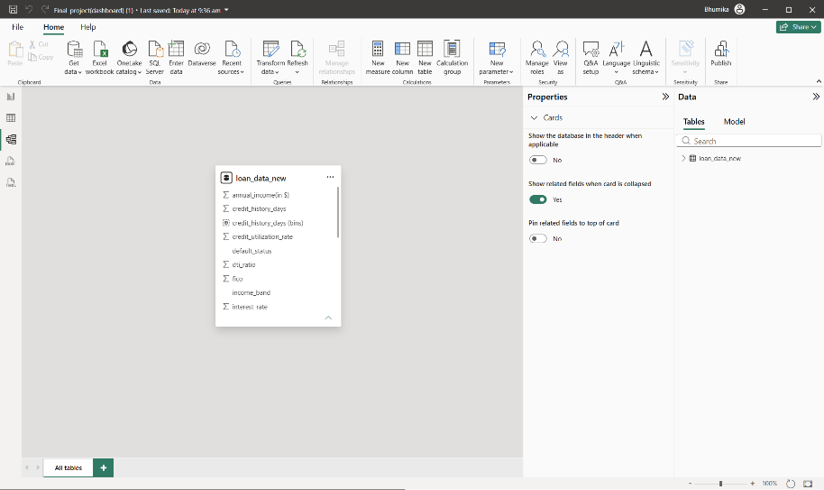
6. Dashboard & Visuals
6.1 Page 1 — Summary / Overview
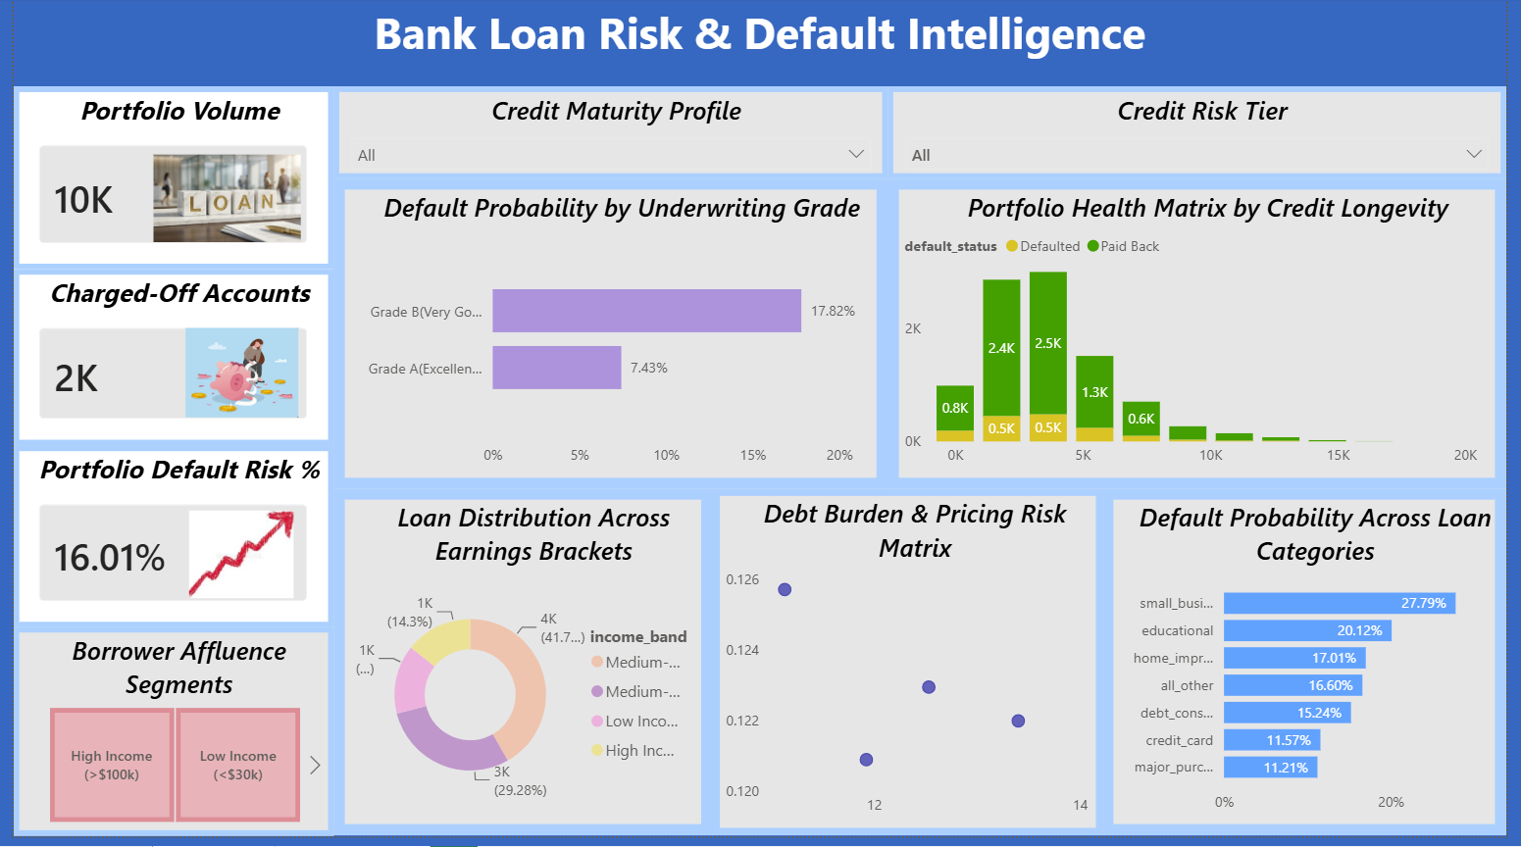
Visuals used on this page:
- KPI Cards — Portfolio Volume, Charged-Off Accounts, and Portfolio Default Risk %.
- Clustered Bar Chart — Default Probability by Underwriting Grade, and Default Probability Across Loan Categories.
- Scatter Plot — Debt Burden & Pricing Risk Matrix.
- Slicer — Borrower Affluence Segments, Credit Maturity Profile, and Credit Risk Tier.
- Stacked Column Chart — Portfolio Health Matrix by Credit Longevity.
- Donut Chart — Loan Distributions Across Earnings Brackets.

Key insight:
The dashboard provides a comprehensive risk profile of the bank's loan portfolio, highlighting a baseline default risk of 16.01%. It reveals that small business loans carry the highest default probability (20.12%), while Grade B loans show a higher risk tier (17.82%) compared to Grade A loans (7.43%). Additionally, the visualization demonstrates how debt burden and credit longevity correlate with default status, allowing for proactive risk management.

6.2 Page 2 — Borrower Profile Page
Visuals used:
- Detailed Table Visual: A granular, row-level reporting grid containing calculated metrics: Sum of annual_income, loan_grade, loan_purpose, Average of dti_ratio, Average of interest_rate, and default_status.

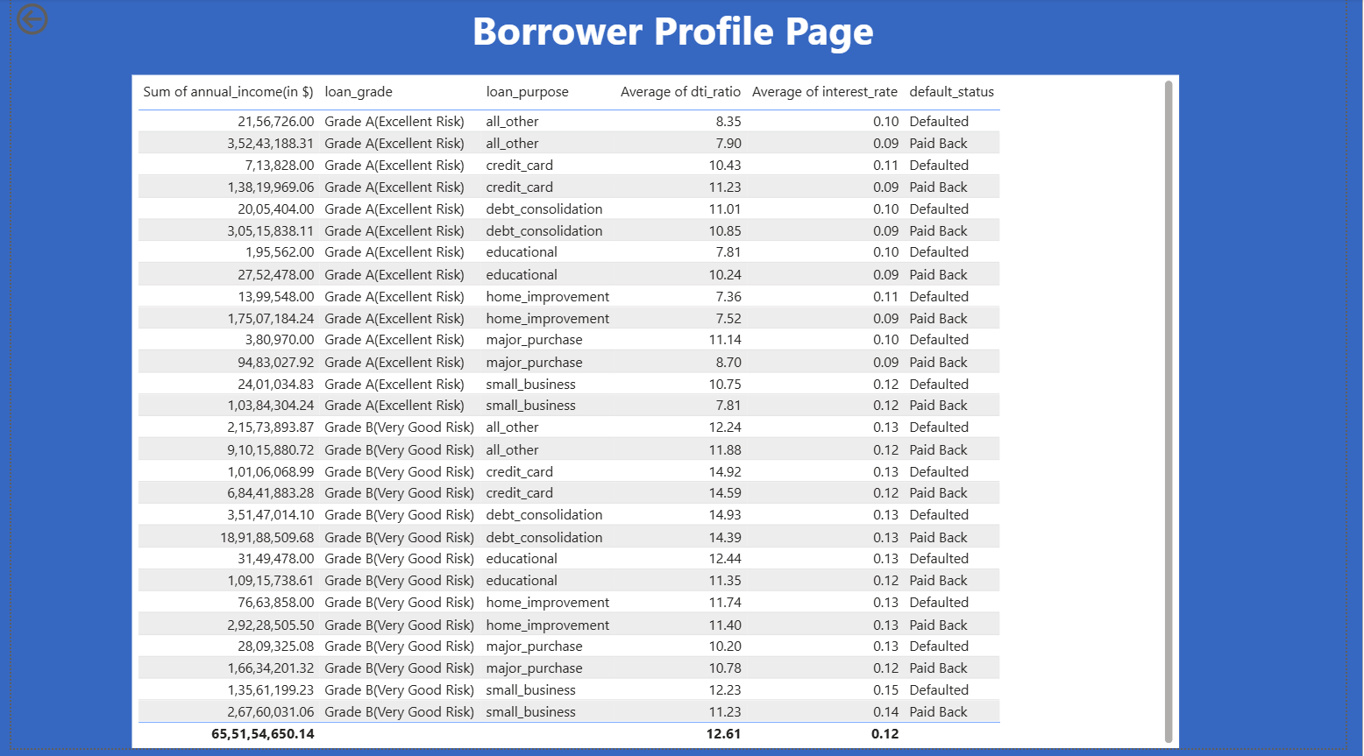

Key insight:
This page acts as an operational ledger, breaking down macro metrics into granular financial records sorted by underwriting grade and intent. It enables risk auditors to investigate specific, high-exposure rows—such as Grade B small business loans with higher average DTI ratios and interest rates—to track exactly which profile segments drive defaults.

7. Key Findings & Insights

An in-depth analysis of the processed loan portfolio dataset reveals critical risk patterns and hidden credit vulnerabilities across various borrower demographics and financial structures:

- The bank maintains an overall portfolio volume of 10K loans with a baseline portfolio default risk of 16.01%.

- Small business loans pose the greatest credit threat, showing an exceptionally high default probability of 27.79%.

- Default probability drops significantly by grade; Grade B accounts have a 17.82% default probability, while safer Grade A accounts drop sharply to 7.43%.

- Credit cards (11.57%) and major purchases (11.21%) represent the safest loan purposes with the lowest default probabilities in the portfolio.

- The donut chart highlights that middle-income segments make up most loan distributions, while high-income and low-income categories remain outlier segments.

- While the bank's overall default rate is 16.01%, high-risk areas like small business loans spike to 27.79%. This instantly flags the exact high-exposure segments where management needs to tighten credit approval policies to minimize losses.

8. Learnings & Challenges

8.1 Skills Learned

- Gained proficiency in handling raw financial datasets by executing initial programmatic integrity checks in Google Colab, followed by advanced text transformations and database flag decoding using Power Query. Building a proper star schema with one-to-many relationships.

- Gained practical knowledge in business intelligence logic computation by engineering custom Data Analysis Expressions (DAX)—including filtering modifications and division safety wrappers—to compute dynamic KPIs like portfolio risk rates. Designing user-friendly dashboards with slicers, drill-through, and cross-filtering.

- Mastered the construction of an optimized Star Schema data model, configuring clean, one-to-many ($1:∞$) filter propagation pathways to bridge key-value relationships between lookup dimension blocks and central transactional fact data.

- Designed a cohesive, dual-layered canvas workspace structured with interactive slicers, cross-filtering matrices, and coordinated colour themes to seamlessly pinpoint critical data anomalies and risk patterns.

8.2 Challenges Faced

- The raw borrower income data was stored entirely as mathematical natural logs (log.annual.inc), which made it impossible to analyse actual currency values or create clear income categories.

- The loan outcome column (default_status) only contained 0s and 1s, which made the final visual charts confusing and difficult to read for anyone looking at the dashboard.

- Initially, keeping all the continuous financial metrics and categorical groups in one massive, flat table started slowing down visual loading speeds and creating overlapping cross-filters.

9. Conclusion

This project successfully addresses the original problem statement by transforming a raw, complex financial dataset into a highly structured data model capable of identifying borrower risk patterns. By executing an end-to-end business intelligence pipeline—spanning data engineering in Python and Excel to modelling in Power BI—the completed dashboard adds immense value to credit risk analysts, enabling them to dynamically filter portfolio metrics and isolate high-exposure credit segments in real time.

If given more time, the next phase of this project would involve implementing a dedicated mobile-optimized layout to enhance accessibility for executives on the move. Additionally, a crucial future scope is the integration of a predictive Machine Learning model, such as a linear regression or classification algorithm. Embedding these predictive analytics directly into the Power BI ecosystem would allow stakeholders to forecast default probabilities for incoming applications, shifting the dashboard from a descriptive tracking tool to a proactive risk-mitigation asset.

Overall, I thoroughly enjoyed building this dashboard from scratch, as it gave me a fantastic opportunity to work through a complete, real-world data workflow. Navigating the process—from writing initial cleanup scripts to designing the final interactive visual interface—has significantly boosted my confidence in turning messy rows of data into useful business insights. It helped me sharpen my hands-on technical skills in Python, Excel formulas, and Power Query, while deeply strengthening my understanding of how tables connect using DAX formulas. This experience has been incredibly rewarding, and it has given me a practical foundation in data analytics that I look forward to using in my future projects.
10. References

- Microsoft Power BI Documentation — https://docs.microsoft.com/en-us/power-bi/
- Microsoft Excel — https://support.microsoft.com/en-us/excel/
- Python — https://docs.python.org/3/
- Dataset Source — https://www.kaggle.com/datasets/urstrulyvikas/lending-club-loan-data-analysis
- DAX Reference Guide — https://learn.microsoft.com/en-us/dax/dax-function-reference
- Power Query M Reference — https://learn.microsoft.com/en-us/powerquery-m/

END OF REPORT

